18.17: Example 18.4 assumes a temperature of 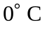at all altitudes and neglects the variation of g with elevation.

With these approximations, 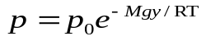
We want y for
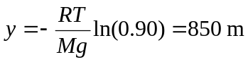
(We have used 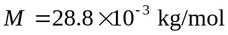for air.)

